Over 30% of staff admit to sleeping with a co-worker at the Christmas party.

Office Christmas party season has arrived and shockingly 31% of workers admitted that they have slept with a co-worker whilst attending their companies Christmas party, a study of over 1000 workers conducted by leading married dating site IllicitEncounters.com has revealed.
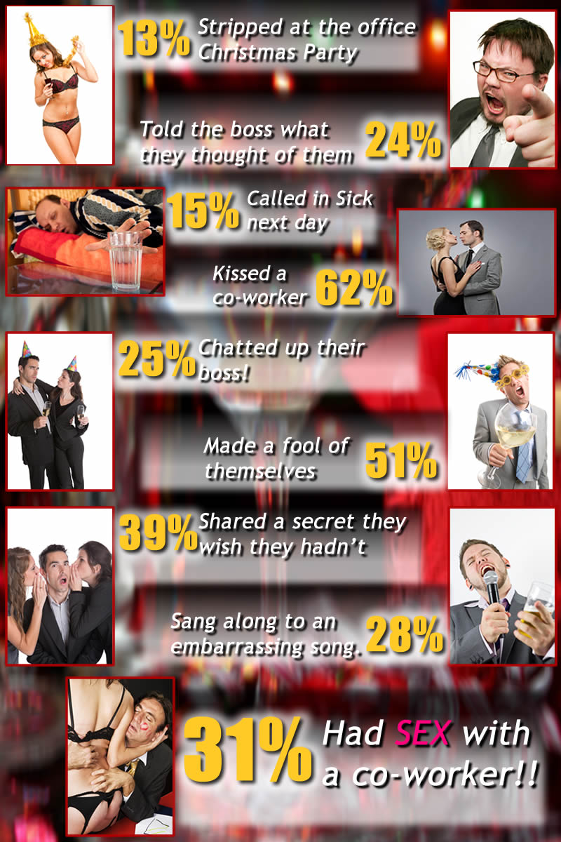

The study also showed that over 60% had kissed someone they work with and 15% admitted to calling in sick the next day with a hangover. In probably quite a poor career move, 24% had used the Christmas party as an opportunity to tell their boss exactly what they thought of them and 25% had decided it would be an appropriate time to chat them up, perhaps trying to secure a pay rise or bonus.

Spokesperson for IllicitEncounters.com Mike Taylor said: “When you work with someone day in and day out you can sometimes form close bonds, mix that with Christmas party environment where alcohol is flowing freely, and people are relaxed and uninhibited, and that is when you are most likely to make compromising decisions and could do something you end up regretting, like chatting up your boss or even kissing or sleeping with a co-worker.

People can forget that there can be long term effects to having a romantic relationship within the work-place, in a resent survey over 80% of employers admitted that having an office based romance would affect the career prospects of those involved.”

Other things staff confessed to doing at Christmas parties included 13% who had stripped off, 39% who had told a secret to someone they wish they hadn't and 28% had sung along to an embarrassing song. Over 50% of party goers revealed that they had done something embarrassing and had made a fool out of themselves in front of their peers and superiors whilst getting carried away in the festivities.

Notes to editors.

The UK's Leading extra-marital affairs website IllicitEncounters.com
It is the UK's largest and longest running dating site for married people.
Established in 2003, we have been providing a meeting place for like-minded married and attached people for nearly 10 years. Our members have one thing in common - they are all looking for a little romance outside their current relationship. Whether that's the occasional bit of flirtatious chat, a regular coffee date, or a full-blown affair, that's up to them.
Office romance stats provided by www.NotAtWork.co.uk
Image and press release downloadable from http://www.mynewsdesk.com/uk/pressroom/illicitencounters/
For more information contact or interviews contact: Mike Taylor - Head of Press
E-mail: PressPR@IllicitEncounters.co.uk
Phone: 020 8819 9936
Twitter @IllicitMike

